Software Project Management Plan (SPMP) for Chatting Application Project

*Baseline version 0.1*

*Issued on : June 20, 2014*

Issued by :

Krisna Pramuji Gunawan

Issued for : Alberto Anditya Aden

# Signature

The following signature indicates approval of the enclosed Software Project Management Plan.

\_\_\_\_\_\_\_\_\_\_\_\_\_\_\_\_\_\_\_\_\_\_\_\_\_\_\_\_\_\_\_\_\_\_\_\_\_\_\_\_\_\_\_

Alberto Anditya Aden

# Change History

|  |  |  |  |
| --- | --- | --- | --- |
| **Version** | **Date** | **Author** | **Changes** |
| 0.1 | August 27, 2014 | Group | Initial Version |
|  |  |  |  |

# Preface

This document delivers the proposed plan to be taken by me to meet the needs of software to complete a Network Project. In order to do so, I will make a program using java programing language in various platforms (Notepad++ & Eclipse) to make our project ideas come to fruition.

This SPMP is intended to be used for the making of Chatting Application. So the lecturer will know our project and how I make the project to a reality.

***Important Notes for Soft-copy Viewing***

This copy of document are delivered in docx format, so please be aware that you must have Microsoft Office installed to your computer especially Microsoft Word if you want to see this document.

# Table of Contents

Contents

[Signature i](#_Toc402255631)

[Change History ii](#_Toc402255632)

[Preface iii](#_Toc402255633)

[Table of Contents iv](#_Toc402255634)

[List of Figures v](#_Toc402255635)

[List of Tables vi](#_Toc402255636)

[Chapter 1 1](#_Toc402255637)

[1.1 Project Overview 1](#_Toc402255638)

[1.1.1 Purpose, Scope, and Objectives 1](#_Toc402255639)

[1.1.2 Assumptions and Constraints 1](#_Toc402255640)

[1.1.3 Project Deliverables 2](#_Toc402255641)

[Chapter 2 3](#_Toc402255642)

[2.1 Software Process Model 3](#_Toc402255643)

[2.2 External Interfaces 3](#_Toc402255644)

[2.3 Internal Structure 3](#_Toc402255645)

[2.4 Roles and Responsibilities 3](#_Toc402255646)

[2.5 Tools and Techniques 4](#_Toc402255647)

[2.5.1. Development Techniques 4](#_Toc402255648)

[2.5.2. Tools 4](#_Toc402255649)

[Chapter 3 5](#_Toc402255650)

[3.1 Work Diagram 5](#_Toc402255651)

[3.2 Responsibility Assignment Matrix (RAM) 6](#_Toc402255652)

[3.3 Activity Diagram 7](#_Toc402255653)

# List of Figures

**External Interface Chart** ….……………………..........................……………………………...3

**Implicit Interface Chart** ………………………………………………………………………..3

# List of Tables

**Work Diagram/Gann Chart**.....………………………………………………………….............6

**Responsibility Assignment Matri**x...............................................................................................7

**Network Diagram**……………………………………………………………………......……….8

# Chapter 1

**INTRODUCTION**

## 1.1 Project Overview

This project consists of the component of a Chatting Apolication and the environment which include:

* Chat Server Handler
* Chat Server
* Chat Client
* IP Address Setting
* Encyption
* Decryption

### 1.1.1 Purpose, Scope, and Objectives

The purpose of this project is to make people could communicate with others easier, and faster, and self setting IP Address, therefore distance won’t be a matter.

The scope in this project are how the the application send a network communication, and how it encrypt and decrypt.

The objectives of the project are mentioned as follows :

* Complete the project by the due date
* Meet all the requirements that are mentioned in the project documentation.

### 1.1.2 Assumptions and Constraints

Here is the list of all assumptions that are made :

* GUI is not the top priority
* Using International System of Units
* IP Address would be set up manually.
* Wrong IP will cause connection issues

Here is the list of all constraints that are made :

* Budget
  + $ 0
* Time
  + 2 months

### 1.1.3 Project Deliverables

The items that we want to deliver are:

* Software program, along with its environment and supporting libraries.
* Software documentation
  + Installation documentation
  + End-user documentation
* Installation of software program along with its environment and supporting libraries.
* Project documentation
  + Software Project Management Plan (SPMP)
  + Software Requirement Specification (SRS)
  + Software Design Description (SDD)
  + Software Test Documentation (STD)
  + Software Test Plan (STP)
  + Software Quality Assurance Plan (SQAP)
  + Software Configuration Management Plan (SCMP)

# Chapter 2

**PROJECT ORGANIZATION**

## 2.1 Software Process Model

This project will undergo the waterfall model because the entire project is plan-driven, so the activities must be schedule first before it was executed.

## 2.2 External Interfaces



## 2.3 Internal Structure



## 

## 2.4 Roles and Responsibilities

Will be attached in Chapter 3.2 Responsibility Assignment Matrix (RAM)

## 2.5 Tools and Techniques

2.5.1. Development Techniques

The project uses eclipse as a program that our group uses to make this project and the techniques that our group will use are Object Oriented techniques such as inheritance, polymorphism, class, encapsulation, etc.

### 2.5.2. Tools

Operating System

* Microsoft Windows 7
* Microsoft Windows 8

Project Management

* Notepad++
* Eclipse

Documentation

* Microsoft Word 2010

# 

# Chapter 3

**PROJECT MANAGEMENT PLAN**

## 3.1 Work Diagram

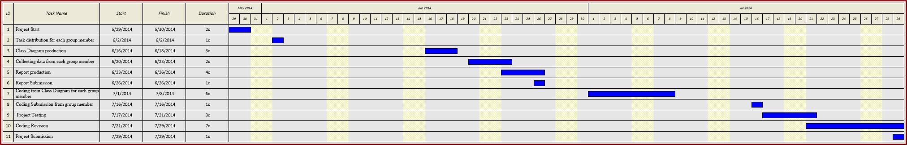

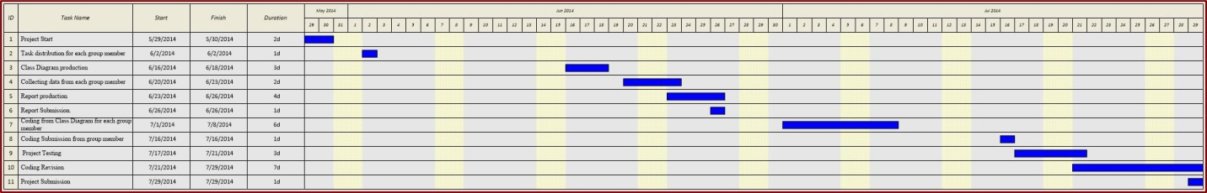

Due to unclearness of the Gantt chart we will include the raw .jpg file so it will make the picture clearer rather than the picture in this word format.

## 3.2 Responsibility Assignment Matrix (RAM) K:\Tugas\RPL_UTS\Capture1.JPG

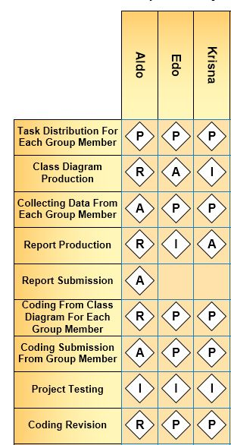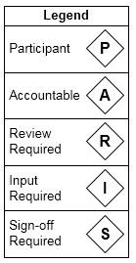

## 3.3 Activity Diagram

